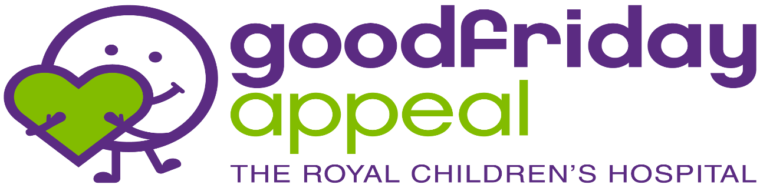
ENTRY FORM
Broadford Golf Club’s Annual
CHARITY GOLF DAY

Saturday 23rd March 2024
Cost per person $80.00 or a Team of four $320.00

Company/Team Name

Name/Handicap/Shirt Size
Player 1 -
Player 2 -
Player 3 -
Player 4 -

Individual Players will be joined into a Team.
Please return by email to: broadfordgc@gmail.com

Team Captain:
Name
Phone/Email
Direct Deposit: Bendigo Bank BSB 633000 Acc. 127773323
(Please write Team Name/Captain as a reference ID)

